**Python Assignment (on 2nd February)**

1. **Explain with an example each when to use “for loop” and “while loop”.**

**i) For loop:** A for loop is used for iterating over a sequence (that is either a list, a tuple, a dictionary, a set, or a string). This is less like the for keyword in other programming languages, and works more like an iterator method as found in other object-oriented programming languages. With the for loop we can execute a set of statements, once for each item in a list, tuple, set etc.

**Syntax**

while(condition):

block of code

**Example**

n=1

while(n<=10):

print(n)

n+=1

**Output**

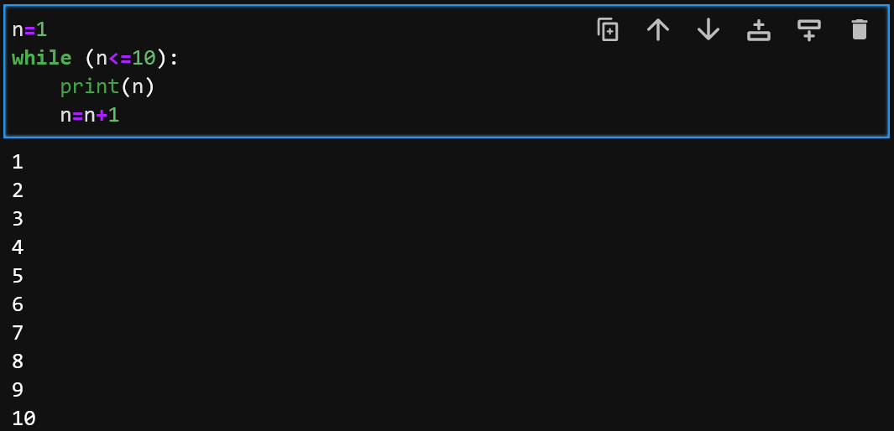

**ii) While loop:** A while loop statement in Python programming language repeatedly executes a target statement as long as a given condition is true. We use “while loop” in Python because if the given condition is true, the loop will iterate with some block of code. When the condition becomes false, program control passes to the line immediately following the loop. In Python, all the statements indented by the same number of character spaces after a programming construct are considered to be part of a single block of code. Python uses indentation as its method of grouping statements.

**Syntax**

for (iterator variable) in (some sequence):

block of code

**Example (With Output)**

